**Azure Functions Lab**

In this Lab, we are going to create an Azure Functions triggered by an HTTP request, and update an Azure SQL database with the contents of HTTP request.

**Create an Azure SQL Database as Follows:**

1. Navigate to the Azure portal at <https://portal.azure.com>, Create Resource and select Databases

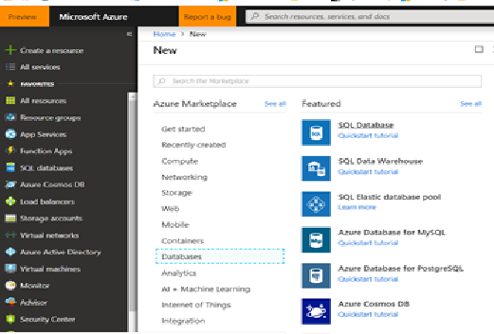

Select Basic Pricing Tier, and enter server details as follows:

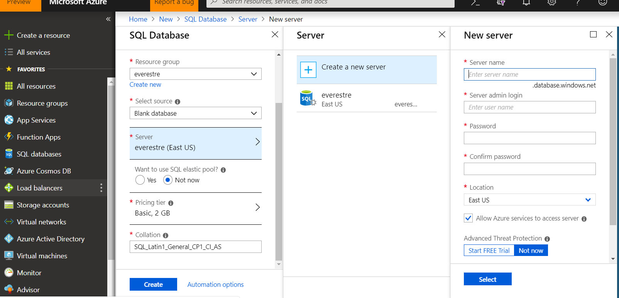

Click Create.

After the database got created, login to the Database through the Query Explorer (Preview):

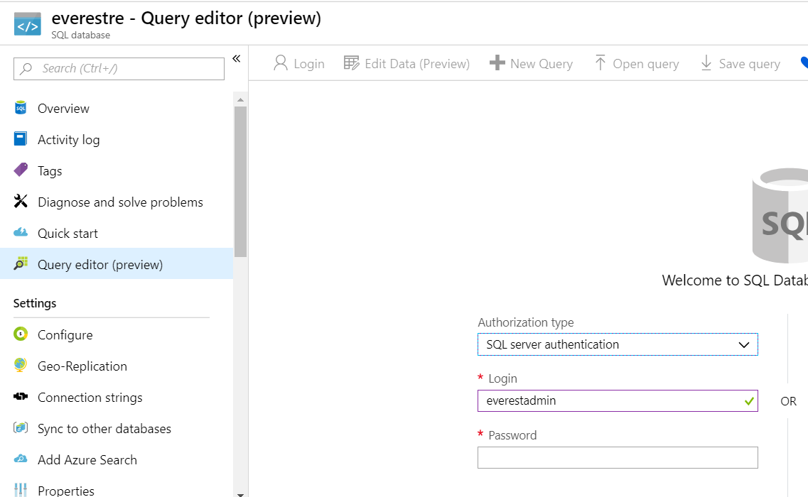

Create a New table by running the following statement:

CREATE TABLE [dbo].[VEHICLE_QUOTE]

(

[Id] INT IDENTITY(1,1) PRIMARY KEY,

[FirstName] VARCHAR(50) NULL,

[LastName] VARCHAR(50) NULL,

[Year] VARCHAR(4) NULL,

[Make] VARCHAR(20) NULL,

[Model] VARCHAR(20) NULL

)

**Create an Azure Function From Visual Studio**

From within Visual Studio, select File 🡪 New Project

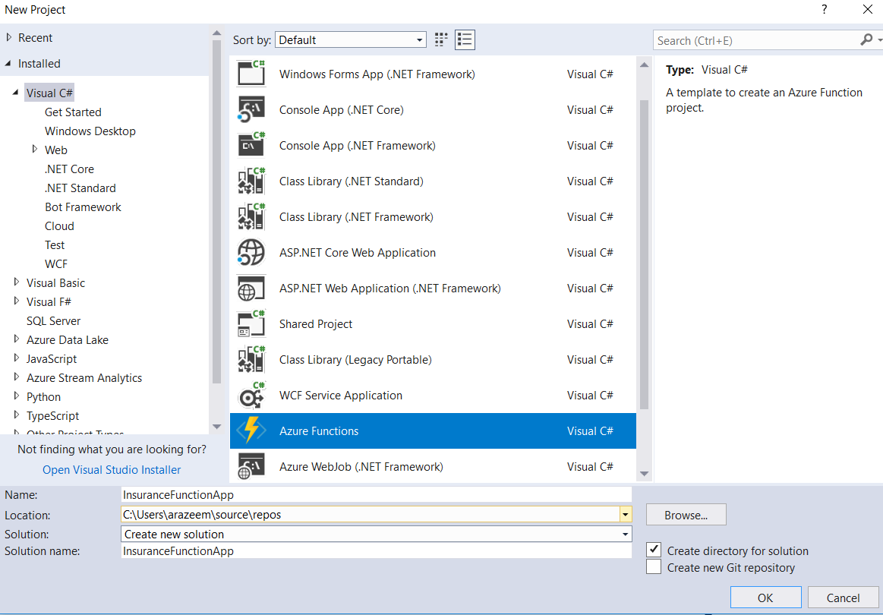

Select an “empty” Function App

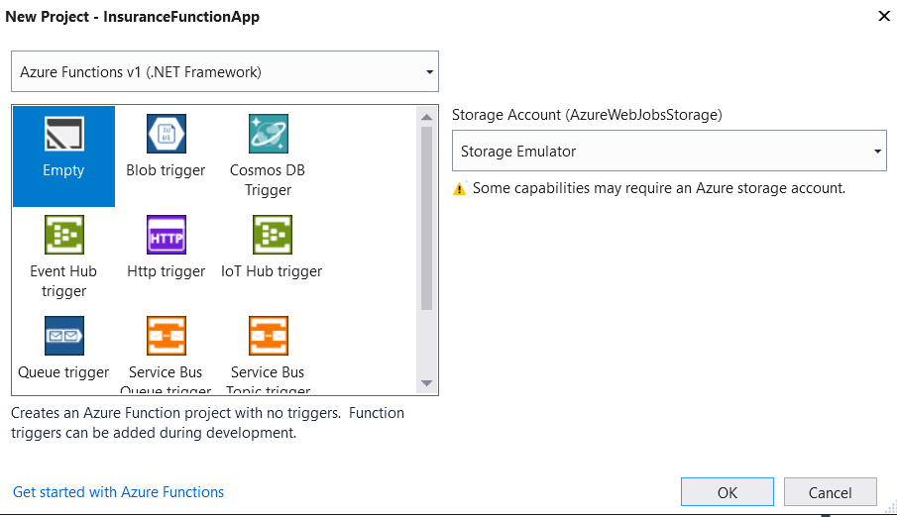

In the Solution Explorer, Right Click -🡪 Add New Azure Function (Might have to do Add 🡪 New Item 🡪 and search for Azure Function)

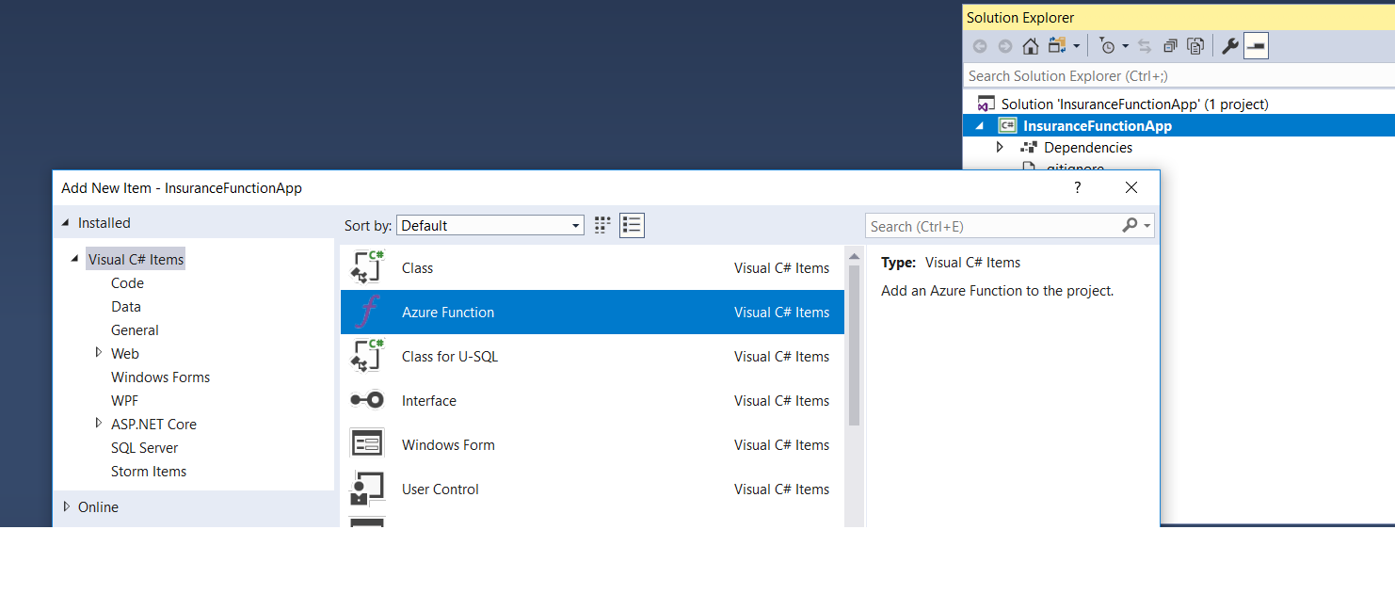

Select **HttpTrigger**, and “**Anonymous**” from the Access rights dropdown as shown below

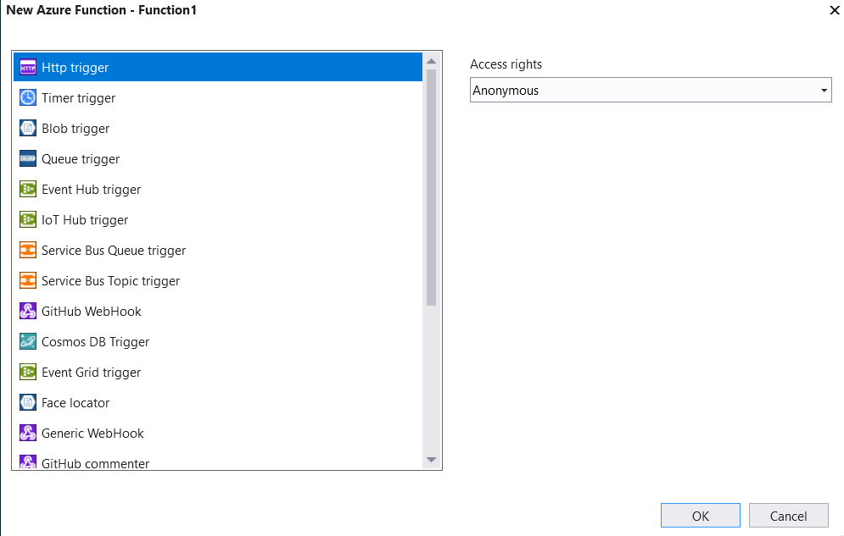

This creates a base template from which we need to build upon.

To run functions locally, we need to install the azure-functions-core-tools. Please refer to <https://marketplace.visualstudio.com/items?itemName=ms-azuretools.vscode-azurefunctions> for installation instructions.

**Write/Update code to parse the Http Request and update to the Database**

* Please refer to the “InsuranceFuncApp” that has been provided for sample code, plug the code in to your new function app accordingly (Make sure the database connection information in the DAO class matches your own DB instance).
* F5 from visual studio to run it locally.
* Use a REST client to test the request (I use Postman from <https://www.getpostman.com/>).

Here is a sample Test request:

"FirstName" : "John",

"LastName" : "Smith",

"Age" : 35,

"vehicle" : {

"Year" : 2001,

"Make" : "Honda",

"Model" : "Accord"

}

}

Once you have verified that the function works locally, Right Click on your Project in Visual Studio and Click “Publish”.

Create a New Profile when prompted, e.g.:

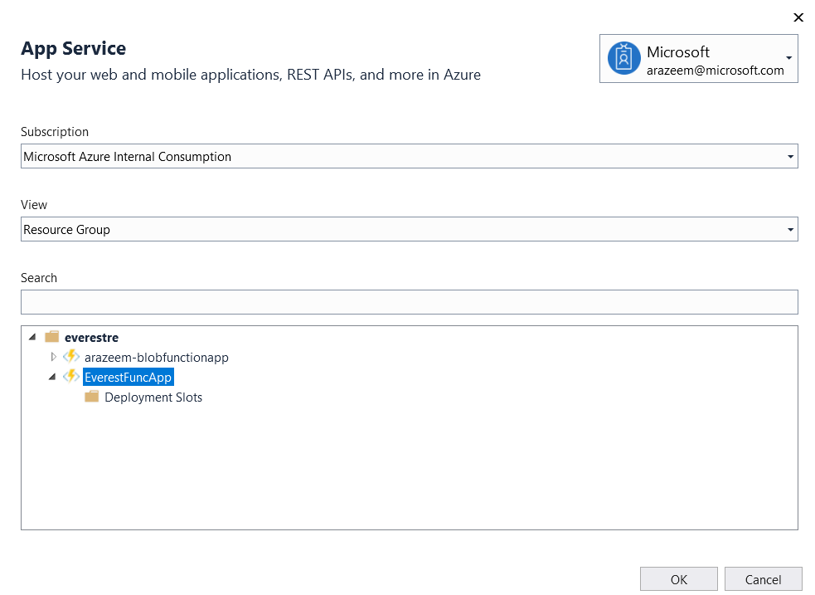

Once the app gets published successful, navigate to the portal, select your Function app, select the function and click on “Get Function URL” as shown in the following example:

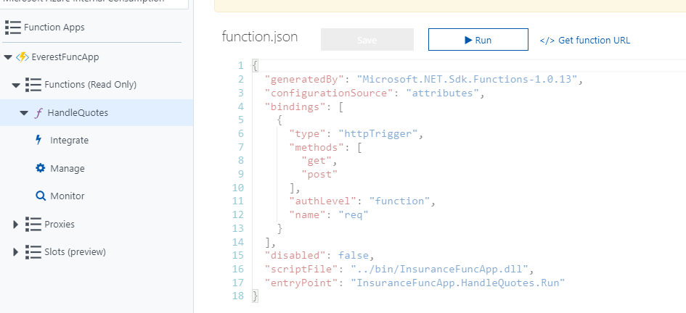

Copy the URL, and test the request through a REST Client.

Summary: By the end of this exercise, we should be able to:

1. Create a Function App and Function from Visual Studio using Http Triggers.
2. Test the function locally using azure functions core tools.
3. Publish the function to Azure from Visual Studio
4. Test the function in Azure